**5. Android Table Layout with Examples**

In android, **TableLayout** is a **ViewGroup** subclass which is used to display the child View elements in rows and columns.

Following is the pictorial representation of table layout in android applications.

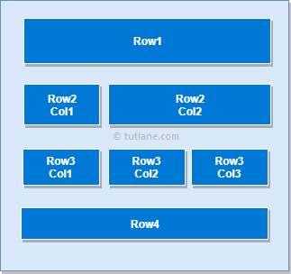

In android, TableLayout will position its children elements into rows and columns and it won’t display any border lines for rows, columns or cells.

The TableLayout in android will work same as HTML table and table will have as many columns as the row with the most cells. The TableLayout can be explained as **<table>** and TableRow is like **<tr>** element.

**Android TableLayout Example**

Following is the example of creating a **TableLayout** with different controls in android application.

Create a new android application using android studio and give names as **TableLayout**. In case if you are not aware of creating an app in android studio check this article [Android Hello World App](https://www.tutlane.com/tutorial/android/android-hello-world-app-example).

Now open an **activity_main.xml** file from **\res\layout** path and write the code like as shown below

**activity_main.xml**

<?xml version="1.0" encoding="utf-8"?>  
<TableLayout xmlns:android="http://schemas.android.com/apk/res/android"  
    android:layout_width="match_parent"  
    android:layout_height="match_parent"  
    android:layout_marginTop="100dp"  
    android:paddingLeft="10dp"  
    android:paddingRight="10dp" >  
    <TableRow android:background="#0079D6" android:padding="5dp">  
        <TextView  
            android:layout_width="wrap_content"  
            android:layout_height="wrap_content"  
            android:layout_weight="1"  
            android:text="UserId" />  
        <TextView  
            android:layout_width="wrap_content"  
            android:layout_height="wrap_content"  
            android:layout_weight="1"  
            android:text="User Name" />  
        <TextView  
            android:layout_width="wrap_content"  
            android:layout_height="wrap_content"  
            android:layout_weight="1"  
            android:text="Location" />  
    </TableRow>  
    <TableRow android:background="#DAE8FC" android:padding="5dp">  
        <TextView  
            android:layout_width="wrap_content"  
            android:layout_height="wrap_content"  
            android:layout_weight="1"  
            android:text="1" />  
        <TextView  
            android:layout_width="wrap_content"  
            android:layout_height="wrap_content"  
            android:layout_weight="1"  
            android:text="Suresh Dasari" />  
        <TextView  
            android:layout_width="wrap_content"  
            android:layout_height="wrap_content"  
            android:layout_weight="1"  
            android:text="Hyderabad" />  
    </TableRow>  
    <TableRow android:background="#DAE8FC" android:padding="5dp">  
        <TextView  
            android:layout_width="wrap_content"  
            android:layout_height="wrap_content"  
            android:layout_weight="1"  
            android:text="2" />  
        <TextView  
            android:layout_width="wrap_content"  
            android:layout_height="wrap_content"  
            android:layout_weight="1"  
            android:text="Rohini Alavala" />  
        <TextView  
            android:layout_width="wrap_content"  
            android:layout_height="wrap_content"  
            android:layout_weight="1"  
            android:text="Guntur" />  
    </TableRow>  
    <TableRow android:background="#DAE8FC" android:padding="5dp">  
        <TextView  
            android:layout_width="wrap_content"  
            android:layout_height="wrap_content"  
            android:layout_weight="1"  
            android:text="3" />  
        <TextView  
            android:layout_width="wrap_content"  
            android:layout_height="wrap_content"  
            android:layout_weight="1"  
            android:text="Trishika Dasari" />  
        <TextView  
            android:layout_width="wrap_content"  
            android:layout_height="wrap_content"  
            android:layout_weight="1"  
            android:text="Guntur" />  
    </TableRow>  
</TableLayout>

Once we are done with creation of layout, we need to load the XML layout resource from our [activity](https://www.tutlane.com/tutorial/android/android-activity-lifecycle) **onCreate()** callback method, for that open main activity file **MainActivity.java** from **\java\com.tutlane.tablelayout** path and write the code like as shown below.

**MainActivity.java**

package com.tutlane.linearlayout;  
import android.support.v7.app.AppCompatActivity;  
import android.os.Bundle;  
  
public class MainActivity extends AppCompatActivity {  
    @Override  
    protected void onCreate(Bundle savedInstanceState) {  
        super.onCreate(savedInstanceState);  
        setContentView(R.layout.activity_main);  
    }  
}

If observe above code, we are calling our layout using **setContentView** method in the form of **R.layout.layout_file_name**. Here our xml file name is **activity_main.xml** so we used file name **activity_main**.

Generally, during the launch of our [activity](https://www.tutlane.com/tutorial/android/android-activity-lifecycle), **onCreate()** callback method will be called by android framework to get the required layout for an [activity](https://www.tutlane.com/tutorial/android/android-activity-lifecycle).

**Output**

When we run above example using android virtual device (AVD) we will get a result like as shown below.

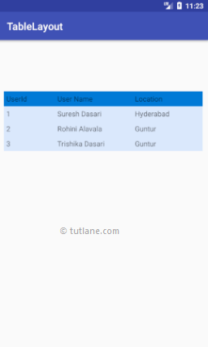

This is how we can use table layout in android applications based on our requirements.